EXPERIMENTS
NAME:S Surender
REG NO:1924260070
COURSE CODE:DSA0601 DATA HANDLING AND
VISUALIZATION
SET 8 – EMPLOYEE PERFORMANCE ANALYSIS
EmployeeID | Department | YearsofService | PerformanceScore
1 | Sales | 5 | 85
2 | HR | 3 | 92
3 | Marketing | 7 | 78
QUESTION 1
Create a line chart to visualize the performance trend of employees over time.
Label the axes and title the chart.
AIM
To create a line chart showing the performance trend of employees based on their
years of service.
PROCEDURE
1. Create the employee performance dataset.
2. Store Employee ID, Department, Years of Service and Performance Score.
3. Use plot() to create a line chart.
4. Use Years of Service on the X-axis.
5. Use Performance Score on the Y-axis.
6. Add axis labels and a suitable title.
CODE
employee <- data.frame(
Employee_ID = c(1, 2, 3),
Department = c("Sales", "HR", "Marketing"),
Years_of_Service = c(5, 3, 7),
Performance_Score = c(85, 92, 78)
)
employee <- employee[order(employee$Years_of_Service), ]



plot(
employee$Years_of_Service,
employee$Performance_Score,
type = "o",
xlab = "Years of Service",
ylab = "Performance Score",
main = "Employee Performance Trend"
)
OUTPUT
Employee Performance Trend

3 | 4 | 5 | 6 | 7
Years of Service
RESULT
Thus, the line chart representing the employee performance trend was successfully
created.

QUESTION 2
Generate a bar chart showing the distribution of employees across different
departments. Label the chart elements.
AIM
To create a bar chart showing the number of employees in each department.
PROCEDURE
1. Create the employee performance dataset.
2. Count the employees in each department.
3. Use the table() function.
4. Use the barplot() function.
5. Add suitable axis labels and a title.
CODE
employee <- data.frame(
Employee_ID = c(1, 2, 3),
Department = c("Sales", "HR", "Marketing"),
Years_of_Service = c(5, 3, 7),
Performance_Score = c(85, 92, 78)
)
department_count <- table(employee$Department)
barplot(
department_count,
xlab = "Department",
ylab = "Number of Employees",
main = "Employee Distribution by Department"
)
OUTPUT




Employee Distribution by Department

HR | Marketing | Sales
Department
RESULT
Thus, the bar chart showing the distribution of employees across departments was
successfully created.
QUESTION 3
Build a table to display the performance data for each employee. Label the table
elements.
AIM
To create and display a table containing the performance information of each
employee.
PROCEDURE
1. Create the employee performance dataset.
2. Enter Employee ID, Department, Years of Service and Performance Score.
3. Assign suitable column names.
4. Display the data using print().
CODE
employee <- data.frame(
Employee_ID = c(1, 2, 3),
Department = c("Sales", "HR", "Marketing"),
Years_of_Service = c(5, 3, 7),
Performance_Score = c(85, 92, 78)
)

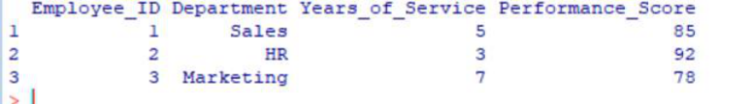

print(employee)
OUTPUT
RESULT
Thus, the employee performance data was successfully displayed in a labelled table.
QUESTION 4
Develop a Tableau dashboard combining the line chart, bar chart, and the table
for interactive exploration of employee performance data.
AIM
To develop an interactive employee performance dashboard using R Shiny by
combining a line chart, bar chart and performance table.
PROCEDURE
1. Create the employee performance dataset.
2. Load the Shiny package.
3. Create the dashboard user interface.
4. Create the line chart for performance trend.
5. Create the bar chart for department distribution.
6. Create the employee performance table.
7. Add a department filter.
8. Run the Shiny application.
9. View the interactive dashboard in the browser.
CODE
library(shiny)
employee <- data.frame(
Employee_ID = c(1, 2, 3),
Department = c("Sales", "HR", "Marketing"),
Years_of_Service = c(5, 3, 7),
Performance_Score = c(85, 92, 78)
)
ui <- fluidPage(
titlePanel("Employee Performance Dashboard"),

sidebarLayout(
sidebarPanel(
selectInput(
"department",
"Select Department:",
choices = c("All", unique(employee$Department))
)
),
mainPanel(
plotOutput("linePlot"),
plotOutput("barPlot"),
tableOutput("employeeTable")
)
)
)
server <- function(input, output) {
filteredData <- reactive({
if (input$department == "All") {
employee
} else {
employee[employee$Department == input$department, ]
}
})
output$linePlot <- renderPlot({
data <- filteredData()
data <- data[order(data$Years_of_Service), ]
plot(
data$Years_of_Service,
data$Performance_Score,
type = "o",
xlab = "Years of Service",
ylab = "Performance Score",
main = "Employee Performance Trend"
)
})
output$barPlot <- renderPlot({
data <- filteredData()
department_count <- table(data$Department)
barplot(
department_count,
xlab = "Department",

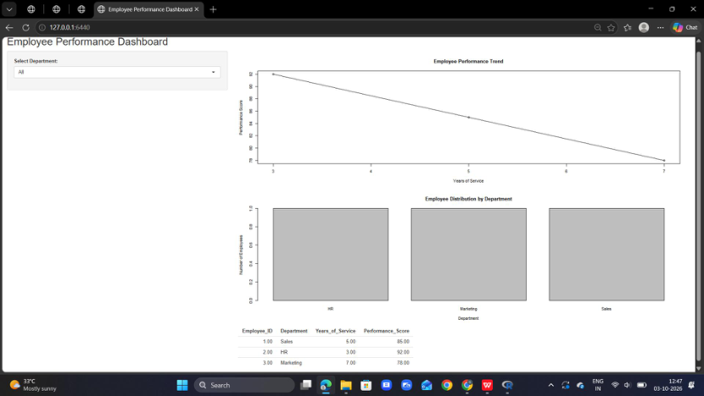

ylab = "Number of Employees",
main = "Employee Distribution by Department"
)
})
output$employeeTable <- renderTable({
filteredData()
})
}
shinyApp(ui = ui, server = server)
OUTPUT
RESULT
Thus, an interactive employee performance dashboard containing the line chart, bar
chart and employee performance table was successfully created using R Shiny..

